Lab: Shannon Diversity Index

**Purpose:**

* To employ the concept of the null hypothesis in a scientific experiment.
* To determine the Shannon Diversity Index for two groups of “species.”
* To compare and analyze the two samples using the Shannon method.

**Background:**

A central theme in ecology is **biodiversity,** which often serves as a measure of the overall health of an ecosystem. Declining biodiversity can indicate that the ecosystem is undergoing some type of environmental stress. Further study may then help to pinpoint that stress.

There are many methods that ecologists use to calculate species diversity. The Shannon Diversity Index is a common way of showing that diversity involves not only numbers of different species, but also how well each of these species is represented in different “habitats.” The Shannon value “H” can range from no diversity at 0.0 (think of a Christmas Tree farm) to a maximum diversity of 4.0 (think of a rainforest). These values have no real meaning by themselves, but can be used to compare two communities or the same community at different times. A large value of H indicates that if you randomly pick in your test area, the odds are the second individual will be different from the first. In this investigation your group will collect data from the vehicles in the student and faculty areas of parking at the school.

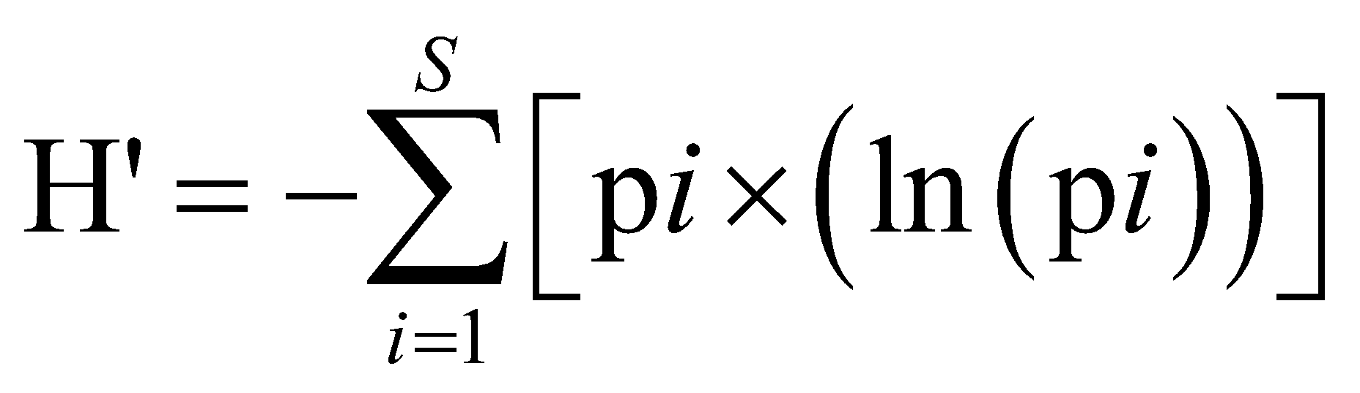

You need to begin with a good hypothesis. This statement needs to show cause and effect between two aspects of the situation being investigated. The standard hypothesis is an “if…then” statement that connects the two aspects being discussed. Experiments of this nature attempt to agree or disagree with the hypothesis. For this lab we will employ a second type of hypothesis, called the **null hypothesis.** This is a statement that there is **no relationship** between the two aspects of the situation under consideration. Experiments of this format are designed to disprove the null hypothesis. Theoretically in science it is easier to disprove something than it is to prove something. The null hypothesis is often the reverse of what the experimenter actually believes; it is put forward to allow the data to contradict it.

**Prelab:**

1. State your null hypothesis here

| There is no correlation between the student parking lot and its biodiversity and the staff parking lot and its biodiversity. |
| --- |

**Materials:**

* vehicles parked at the school/neighborhood
* calculator with natural log function

**Procedure:**

Your team of four people will be divided into two people who will count the vehicles in the faculty area of parking and two who will count the vehicles in the student area of parking. Mr Jones will explain where these areas are located. Fill in one chart completely for each site.

**Results:** see data tables. Fill them in using the calculations below:

**Calculations:**

The Shannon equation is:

H’ = - sum(pilnpi)

Where: H’ = Shannon Diversity Index

pi = the ratio of the number of organisms of a species to the total number of organisms

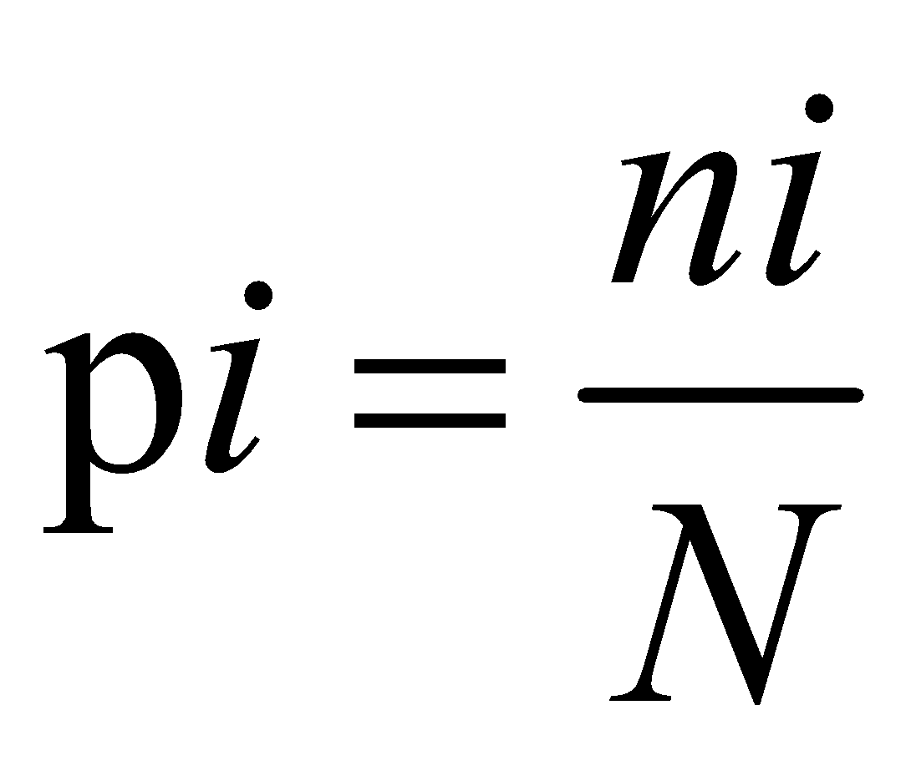 where: *ni*= number of individuals in species “i”

*N*= total number of individuals of all species

lnpi = the natural log of pi

\*\**Note there is a negative sign before the sum sign, which means that your answers will always be positive.*

**Example Data Set**

Parking Lot A:

| Species of Car | Species Identifier Code | Number of Individuals in Parking Lot A |  |  |  |
| --- | --- | --- | --- | --- | --- |
| I | ni | pi | ln(pi) | pi (ln(pi)) |
| Sedan (4-door or 2-door with regular trunk) | 1 | 10 | 0.17 | -1.79 | -0.30 |
| SUV (higher off ground, gate in back) | 2 | 10 | 0.17 | -1.79 | -0.30 |
| Van or Mini-Van (sliding doors with hatch in back) | 3 | 10 | 0.17 | -1.79 | -0.30 |
| Pick-Up Truck (cargo in back) | 4 | 10 | 0.17 | -1.79 | -0.30 |
| Station Wagon or Hatchback | 5 | 10 | 0.17 | -1.79 | -0.30 |
| Bikes or Motorcycles | 6 | 10 | 0.17 | -1.79 | -0.30 |
| **TOTAL** | S=6 | N=60 |  |  | -1.79 |

**Therefore H’=1.79**

Parking Lot B:

| Species of Car | Species Identifier Code | Number of Individuals in Parking Lot A |  |  |  |
| --- | --- | --- | --- | --- | --- |
| I | ni | pi | ln(pi) | pi (ln(pi)) |
| Sedan (4-door or 2-door with regular trunk) | 1 | 1 | 0.02 | -4.09 | -0.07 |
| SUV (higher off ground, gate in back) | 2 | 2 | 0.03 | -3.40 | -0.11 |
| Van or Mini-Van (sliding doors with hatch in back) | 3 | 25 | 0.42 | -0.88 | -0.36 |
| Pick-Up Truck (cargo in back) | 4 | 32 | 0.53 | -0.63 | -0.34 |
| Station Wagon or Hatchback | 5 | 0 | n/a | n/a | n/a |
| Bikes or Motorcycles | 6 | 0 | n/a | n/a | n/a |
| **TOTAL** | S=4 | 60 |  |  | -0.88 |

**Therefore H’= 0.88**

**Which parking lot above is more diverse?** Lot A (S=6, H’=1.8). The car species are equally represented in this lot. We say that this parking lot (community) has a high degree of evenness. Lot B is less diverse based on our indexes (S=4, H’=0.88) and has low evenness, because the car species are unequally represented. Pick-up trucks are the most common species in Lot B, followed by Vans. This lot has a high degree of dominance by these two species (p3+p4=.95=95% of the individuals in this parking lot are Trucks and Vans).

| **Diversity Measurement** | **Community A (Lot A)** | **Community B (Lot B)** |
| --- | --- | --- |
| Species richness (S) | 6 species | 4 species |
| Evenness | High | Low |
| Shannon Diversity Index (H’) | 1.79 | 0.88 |
| Overall Diversity | High | Low |

Now collect data

**Student Parking Lot/Neighborhood Street(Lot/Community A)**

| Species of Car | Species Identifier Code | Number of Individuals in Parking Lot A |  |  |  |
| --- | --- | --- | --- | --- | --- |
| I | ni | pi | ln(pi) | pi (ln(pi)) |
| Sedan (4-door or 2-door with regular trunk) | 1 | 40 | 0.194 | -1.640 | -0.318 |
| SUV (higher off ground, gate in back) | 2 | 20 | 0.097 | -2.333 | -0.226 |
| Van or Mini-Van (sliding doors with hatch in back) | 3 | 4 | 0.019 | -3.963 | -0.753 |
| Pick-Up Truck (cargo in back) | 4 | 3 | 0.015 | -4.200 | -0.063 |
| Station Wagon or Hatchback | 5 | 8 | 0.039 | -3.244 | -0.127 |
| Bikes or Motorcycles | 6 | 131 | 0.636 | -0.453 | -0.288 |
| **TOTAL** | | 206 | 1 | -15.833 | -1.775 |

**H’ = 1.775**

**Faculty Parking Lot/Neighborhood Street (Lot/Community B)**

| Species of Car | Species Identifier Code | Number of Individuals in Parking Lot B |  |  |  |
| --- | --- | --- | --- | --- | --- |
| I | ni | pi | ln(pi) | pi (ln(pi)) |
| Sedan (4-door or 2-door with regular trunk) | 1 | 38 | 0.404 | -0.906 | -0.366 |
| SUV (higher off ground, gate in back) | 2 | 37 | 0.394 | -0.93 | -0.366 |
| Van or Mini-Van (sliding doors with hatch in back) | 3 | 1 | 0.011 | -4.54 | -0.048 |
| Pick-Up Truck (cargo in back) | 4 | 5 | 0.053 | -2.933 | -0.156 |
| Station Wagon or Hatchback | 5 | 13 | 0.138 | -1.97 | -0.273 |
| Bikes or Motorcycles | 6 | 0 | 0 | undef | undef |
| **TOTAL** | | 94 | 1 | -11.279 | -1.209 |

**H’ = 1.209**

**Fill in the following chart and use for your analysis:**

| **Diversity Measurement** | **Community A (Lot A)** | **Community B (Lot B)** |
| --- | --- | --- |
| Species richness (S) *(#)* | 6 | 6 |
| Evenness *(high/low)* | Low | Low |
| Shannon Diversity Index (H’) | 1.775 | 1.209 |
| Overall Diversity *(high/low)* | Low | Low |

**Analysis:** Remember to **provide data** to support your answer.

1. Compare the data related to the two communities. Evaluate this in light of your null hypothesis.

| Both communities have the same species richness, both have low overall diversity and evenness. Additionally, both of the parking lots have a relatively low Shannon Diversity Index. The parking lots appear to have no direct correlation. It doesn’t seem to depend on the population occupying the lots (students/teachers). |
| --- |

1. Which species are more dominant in each community? Why do you think this is the case?

| Sedans (species 1) are the most dominant in both communities. I think this is because, most oftenly, everyone that comes to school only has the need to drive themselves or one to two siblings. Most teachers and students don’t need as much space. Sedans offer a good amount of space for one to four people and are typically easier and smaller to drive. |
| --- |

1. Which group, if any, is more diverse? Why do you think this is the case?

| Community A would be more diverse. The Shannon Diversity Index is higher in community A. This could be because for students, there is less option when it comes to which car they can take to school. For teachers, most are driving to school by themselves, and therefore don’t need a ton of space, or can choose the most convenient car to use to arrive at school (sedan or SUV). However, for students, many need to bike, or have to drive harder cars because their parents need use of the most convenient car to drive. |
| --- |

1. Would the Shannon Index be a good comparison for evaluating dinosaur and plant diversity in a fossil bed 150 million years old and one that is 90 million years old? Explain.

| Yes. This is because the Shannon Index is used to measure the number of species and diversity in a certain area. Therefore, using this index would be accurate when comparing the diversity of dinosaurs and plants. |
| --- |